1. **标题样本:**
   1. **公共**
      1. **数据整合,接入与输出**
         1. **集群间的数据同步**
            1. **按key抽样分布分区分片**
2. **如何选择 deep net:**

如果你面对的是unlabeled data, 并希望无监督地寻找数据中的模式:

推荐使用 Restricted Boltzmann Machine (RBM), Autoencoder

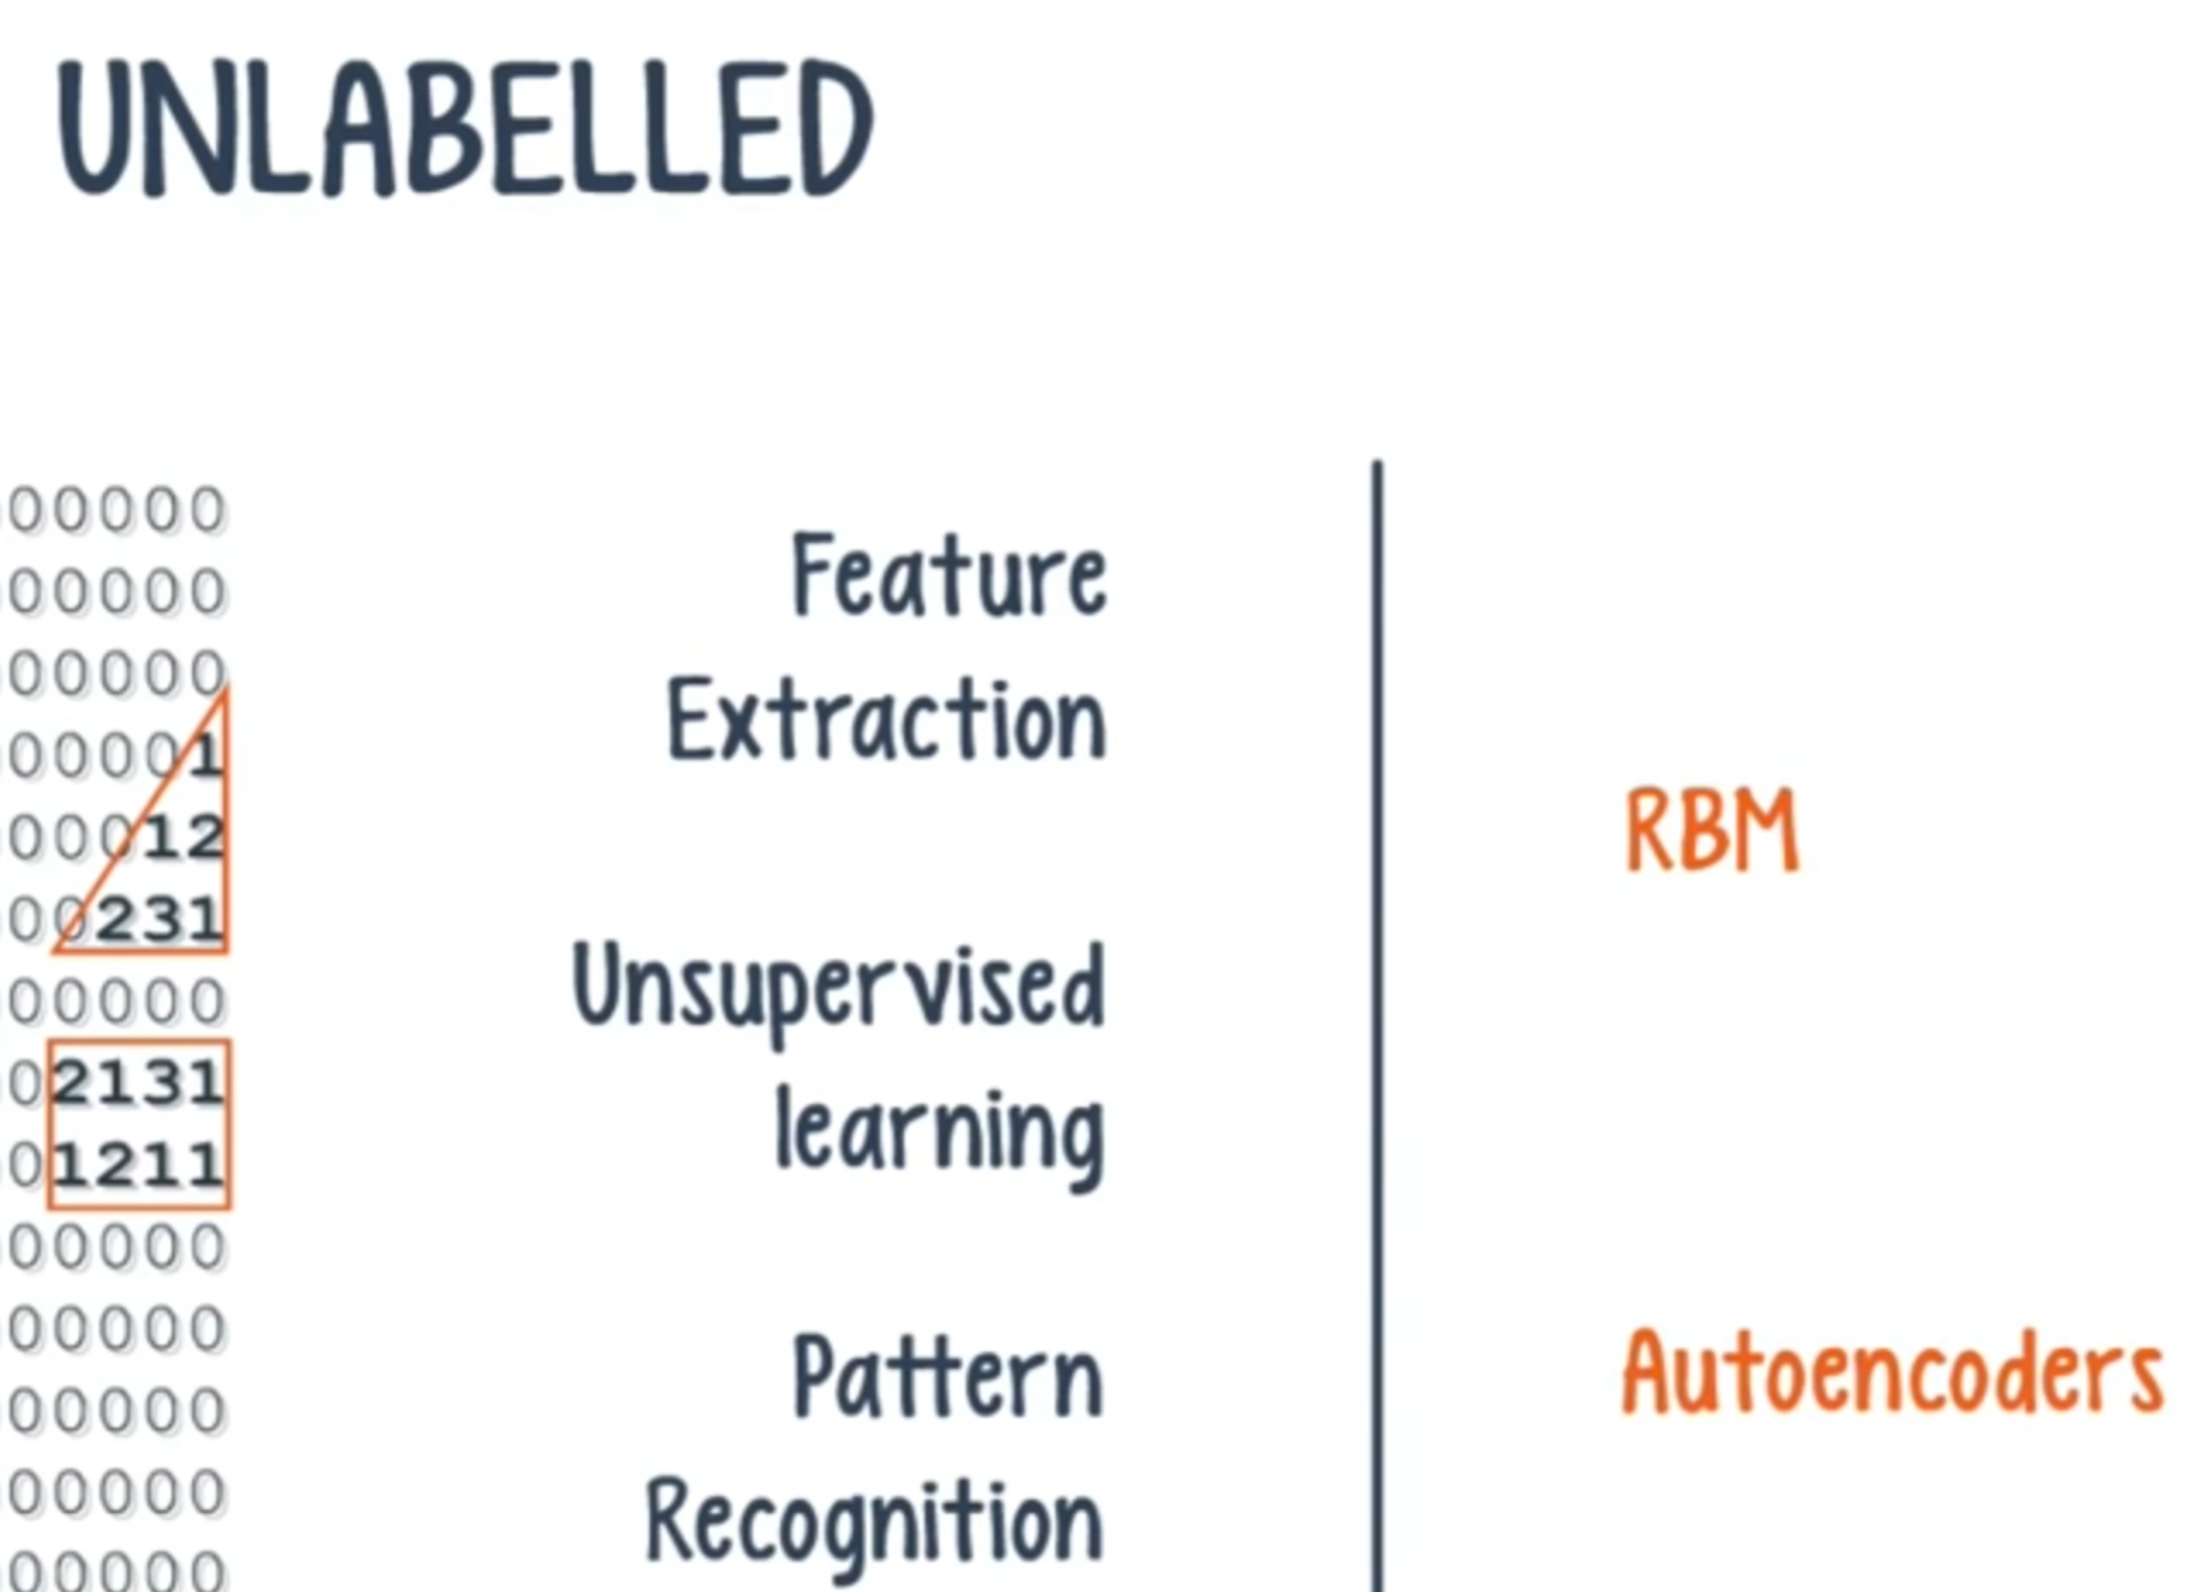

如果你面对的是labeled data, 并希望监督地进行分类学习:

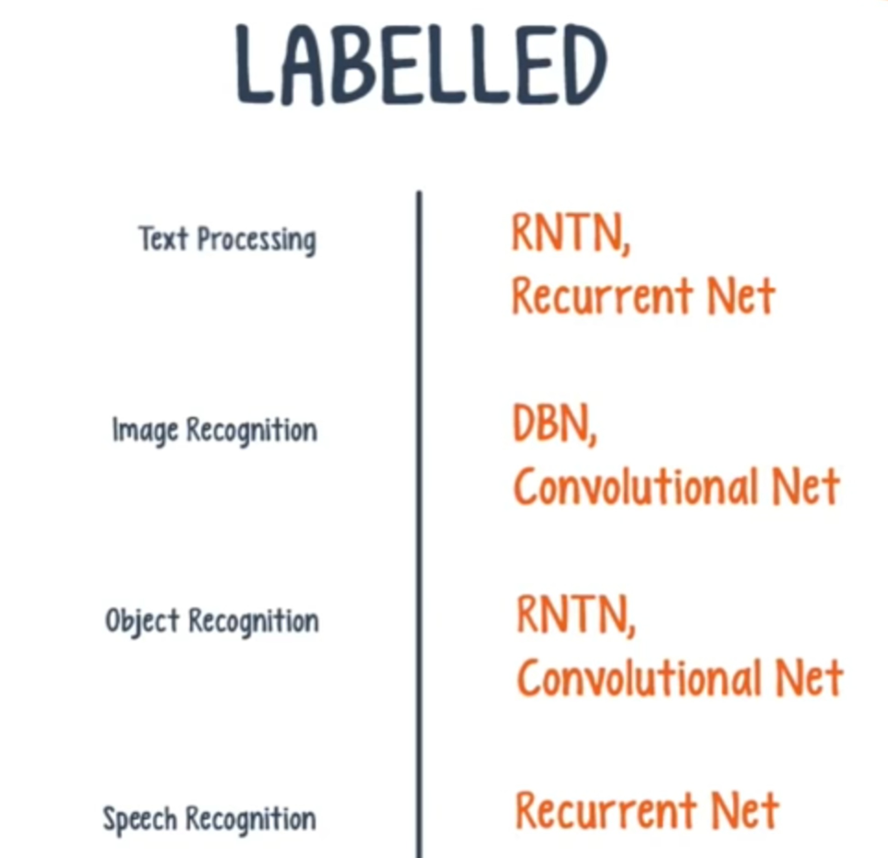

Text Processing: 包括sentiment analysis, parsing, named entity recognition, etc

使用 Recurrent Net, Recursive Neural Tensor Network(RNTN),

基于字词处理的语言模型, 用 Recurrent Net

Image Recognition: 用 Deep Belief Network, Convolutional Net

Object Recognition: 用 Convolutional Net, RNTN

Speech Recognition: 用 Recurrent Net

另外,一般地:

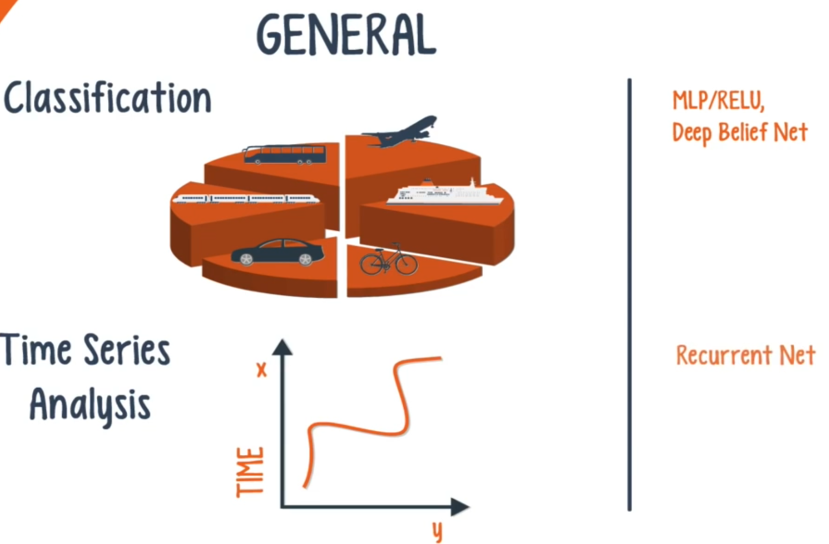

分类学习: 用 Deep Belief Networks, Multilayer Perceptrons with Rectified Linear Units(MLP/RELU)

时间序列分析: 用Recurrent Net

1. **训练Deep Net中的 vanishing gradient 问题**

容易发生vanishing gradient, exploding gradient 导致训练拉长,准确率下降

vanishing gradient: 在计算整个 net 的 loss function 时需要用 back propagate从 output layer 向后逐层计算各 hidden layer 的导数和方差, 在 back propagate 过程中, 方差会不断变小, 进而导致离 output layer 最远的那些 hidden layer 的 gradient 变得很小, 导致整个 network 收敛很慢. 因为一个神经元的方差是前面一层所有神经元的方差的加权累计, 所以当反过来通过某神经元计算前一层的方差时,方差必然会减少, 进而 gradient 减少.

2006年,由于上述问题, deep net 一直很难训练, 直到 Hinton 关于 RBM 和DBN的论文发表.

1. **Restricted Boltzmann Machine (RBM)**

是一种无监督学习法, 可使用 unlabeled data. 通过对输入进行编码和解码来抽取和记忆数据中的重要属性与模式

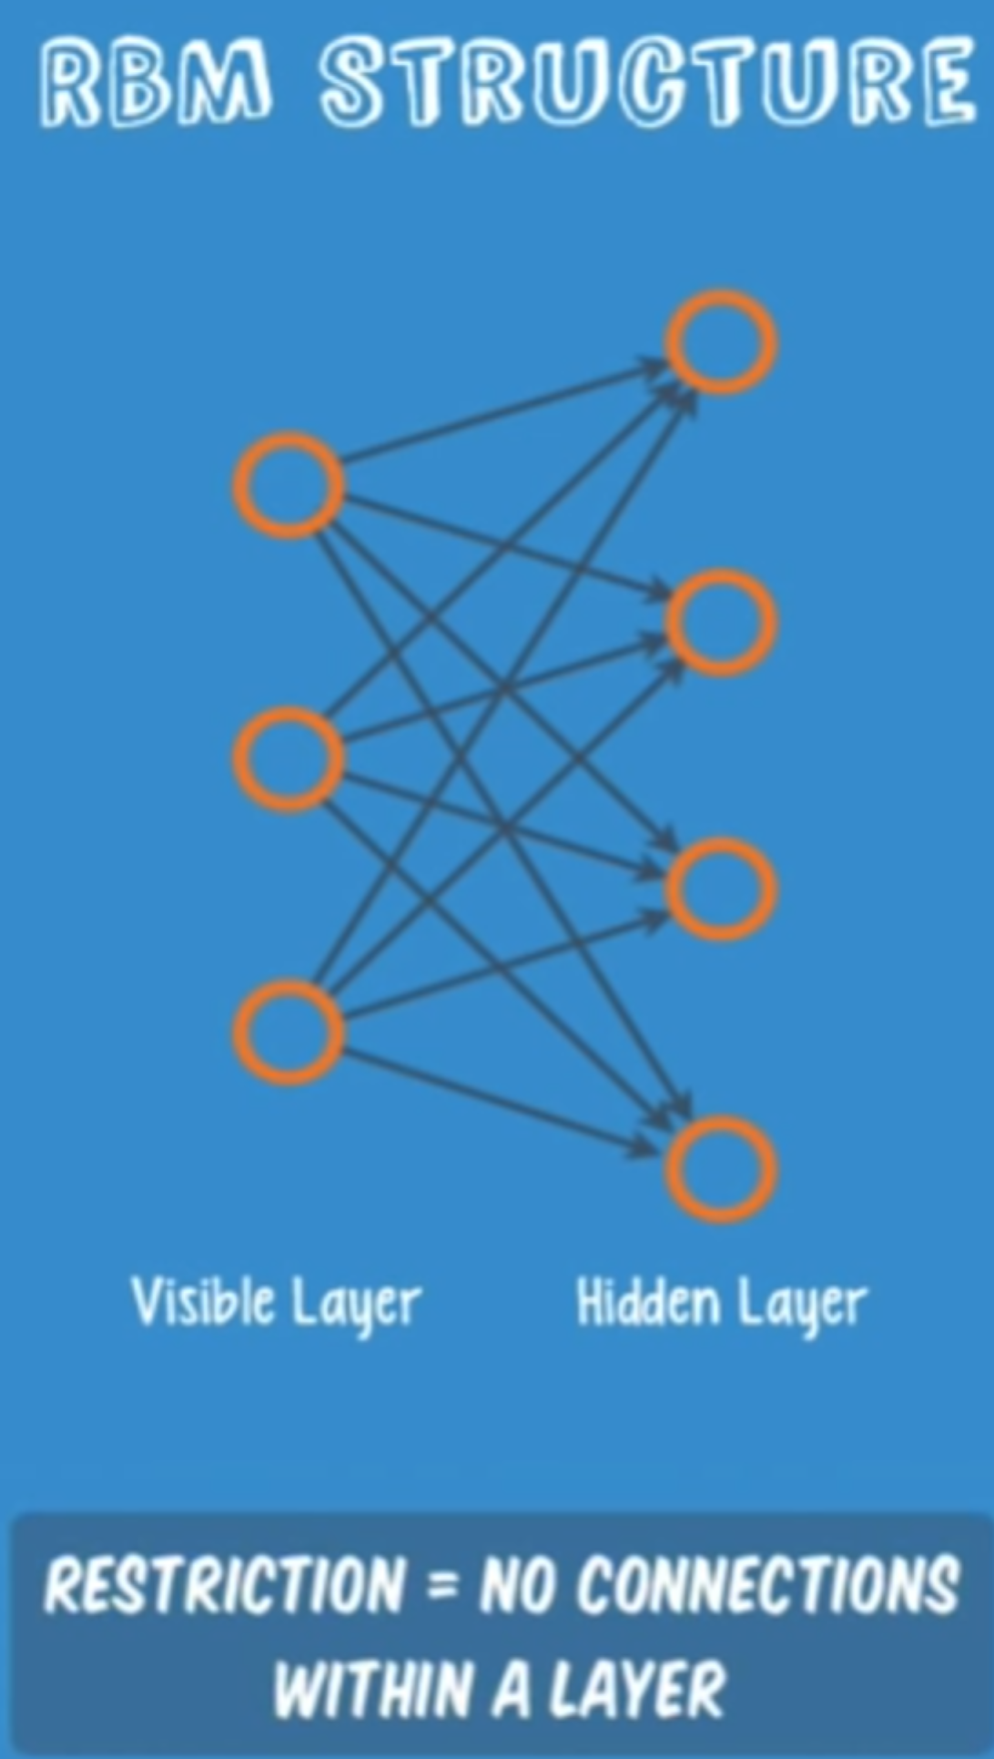

An RBM is a shallow, two-layer net; the first layer is known as the visible layer and the second is called the hidden layer. Each node in the visible layer is connected to every node in the hidden layer. An RBM is considered “restricted” because no two nodes in the same layer share a connection.

An RBM is the mathematical equivalent of a two-way translator – **in the forward pass**, an RBM takes the inputs and translates them into a set of numbers that encode the inputs. **In the backward pass**, it takes this set of numbers and translates them back to form the re-constructed inputs. A well-trained net will be able to perform the backwards translation with a high degree of accuracy. In both steps, the weights and biases have a very important role. They allow the RBM to decipher the interrelationships among the input features, and they also help the RBM decide which input features are the most important when detecting patterns.

* 1. **RBM 的训练就不不断地来回运行以下三步:**

(可参考<神经网络设计>的p105关于自联想存储器, p264关于instar, p268关于outstar)

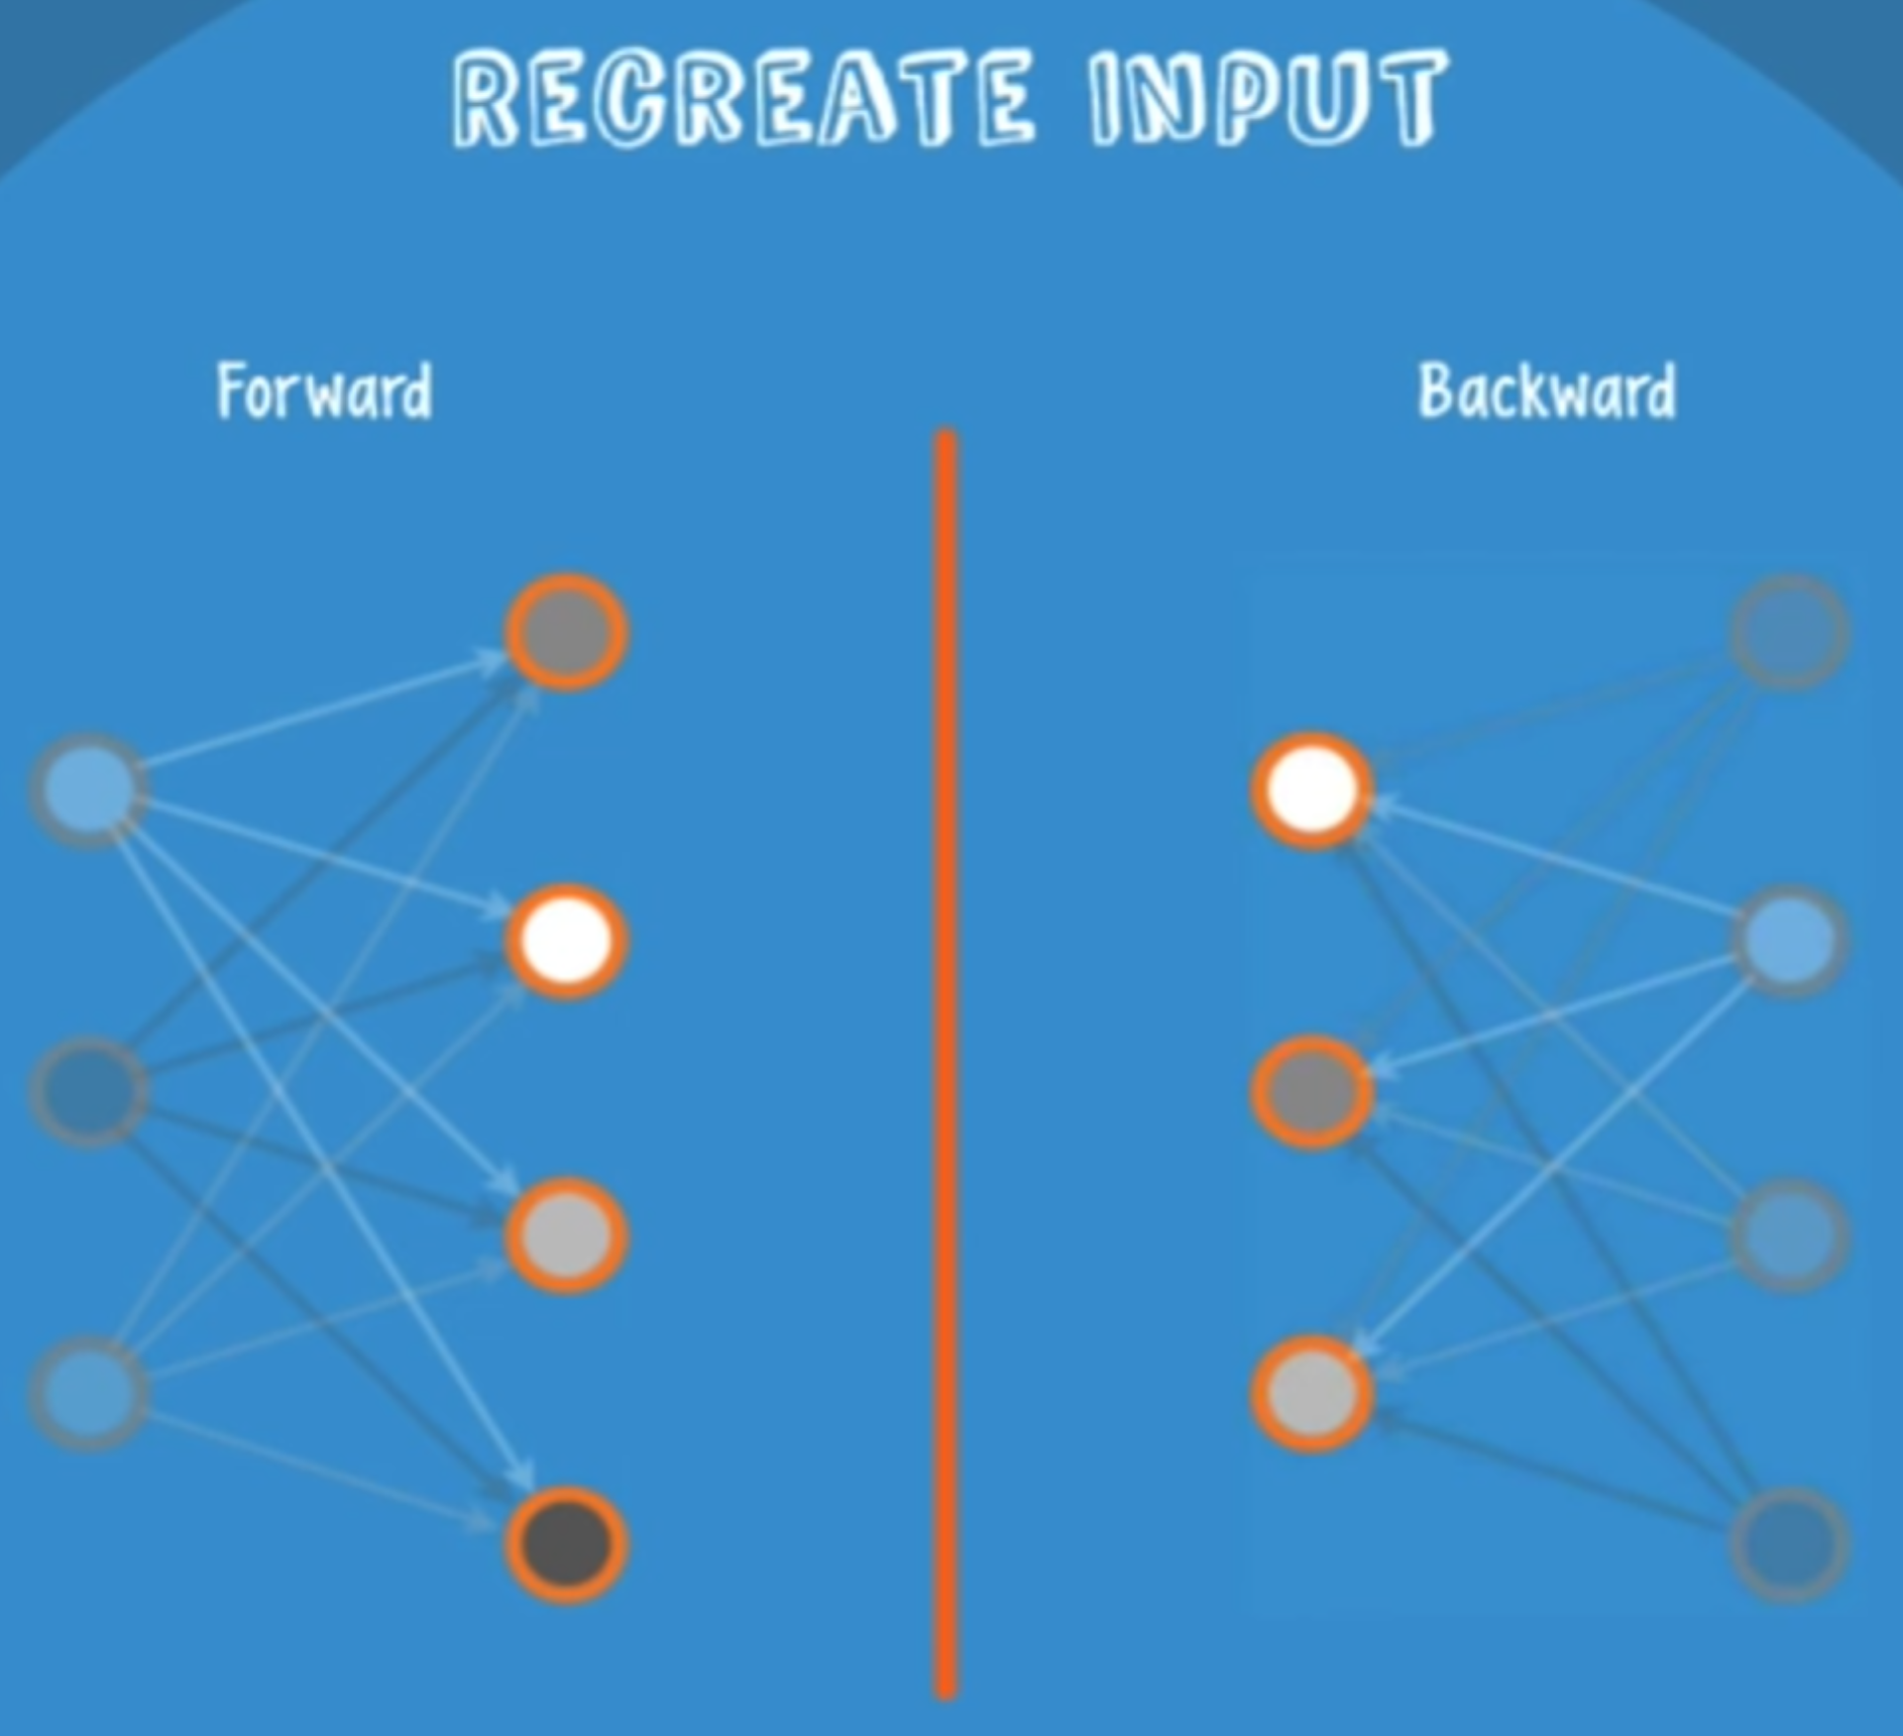

a) With a **forward pass**, every input is combined with an individual weight and one overall bias, and the result is passed to the hidden layer which may or may not activate.

b) Next, in a **backward pass,** each activation is combined with an individual weight and an overall bias, and the result is passed to the visible layer for reconstruction.

c) At the visible layer, the **reconstruction is compared against the original** input to determine the quality of the result.

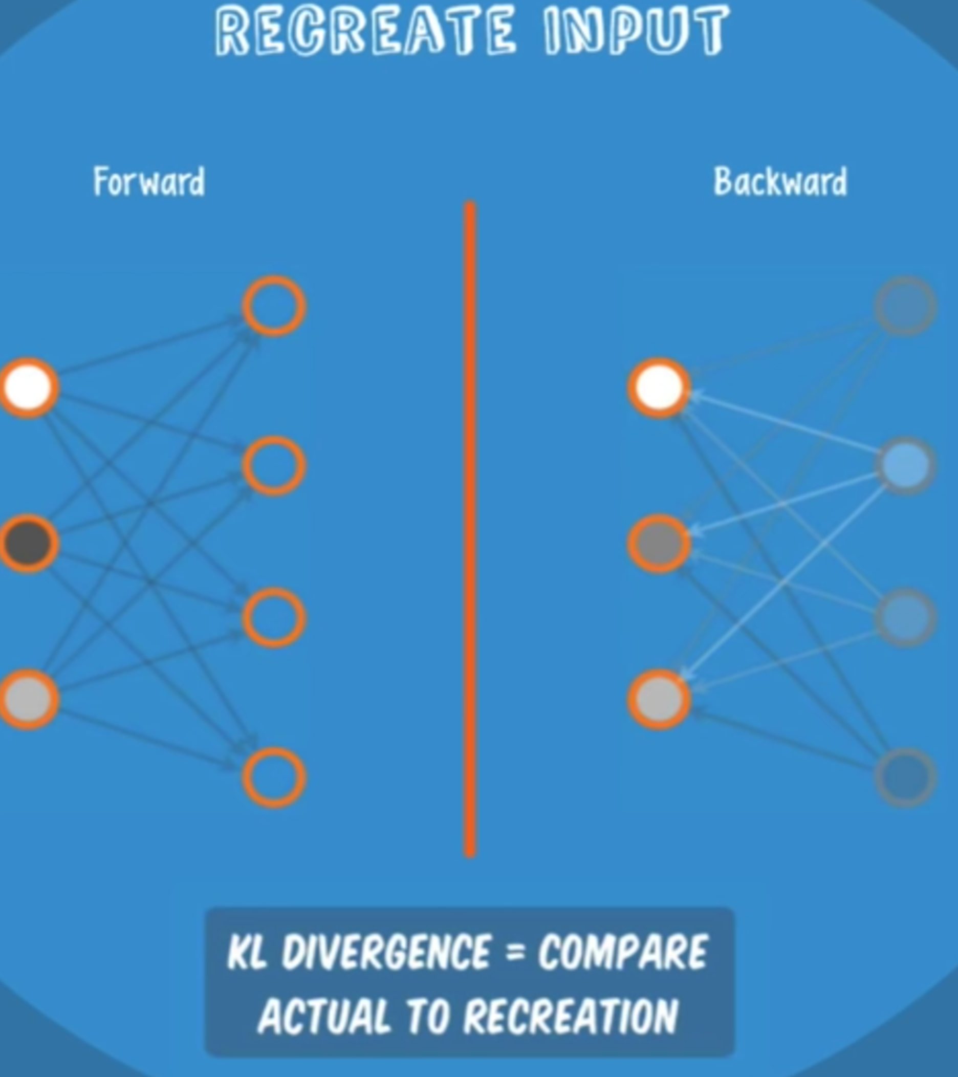

RBMs use a measure called KL Divergence??? for step c);

steps a) thru c) are repeated with varying weights and biases until the input and the re-construction are as close as possible.

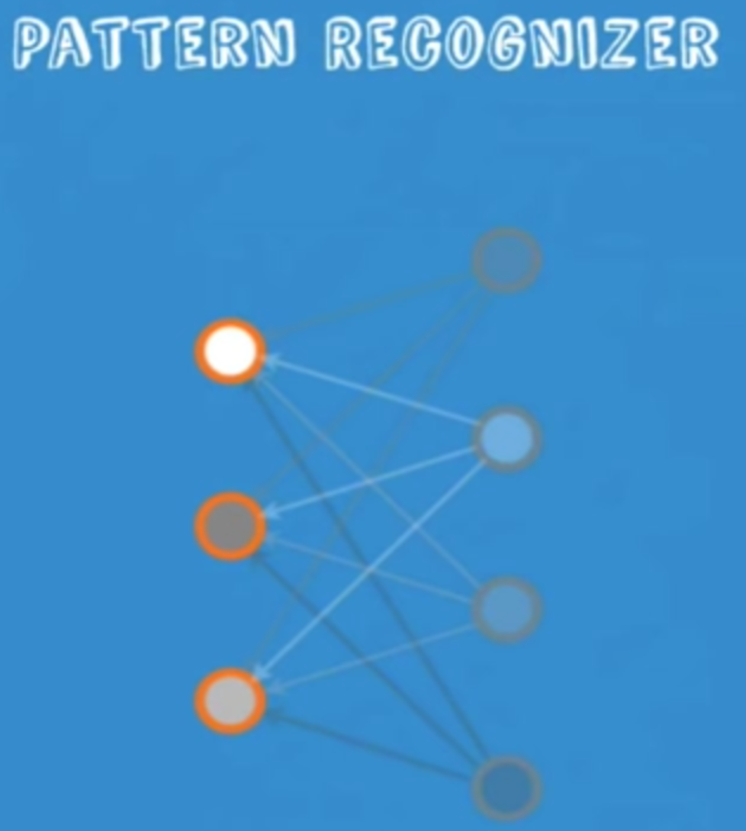

Rather than having people manually label the data and introduce errors, an RBM automatically sorts through the data, and by properly adjusting the weights and biases, an RBM is able to extract the important features and reconstruct the input.

An important note is that an RBM is actually making decisions about which input features are important and how they should be combined to form patterns.

In other words, an RBM is part of a family of feature extractor neural nets, which are all designed to recognize inherent patterns in data. These nets are also called autoencoders, because in a way, they have to encode their own structure. 参考: AndrewNG的 DL 课程 http://deeplearning.stanford.edu/wiki/index.php/UFLDL%E6%95%99%E7%A8%8B

1. **Deep Belief Network (DBN)**

可参考<栈式自编码机> http://deeplearning.stanford.edu/wiki/index.php/Stacked_Autoencoders

* 1. **结构:**

In terms of network structure, a DBN is identical to an MLP. But when it comes to training, they are entirely different. In fact, the difference in training methods is the key factor that enables DBNs to outperform their shallow counterparts.

A deep belief network can be viewed as a stack of RBMs, where the hidden layer of one RBM is the visible layer of the one "above" it. 如下:

* 1. **预训练:**

A DBN is trained as follows:

a) The first RBM is trained to re-construct its input as accurately as possible

b) The hidden layer of the first RBM is treated as the visible layer for the second and the second RBM is trained using the outputs from the first RBM . 如下:

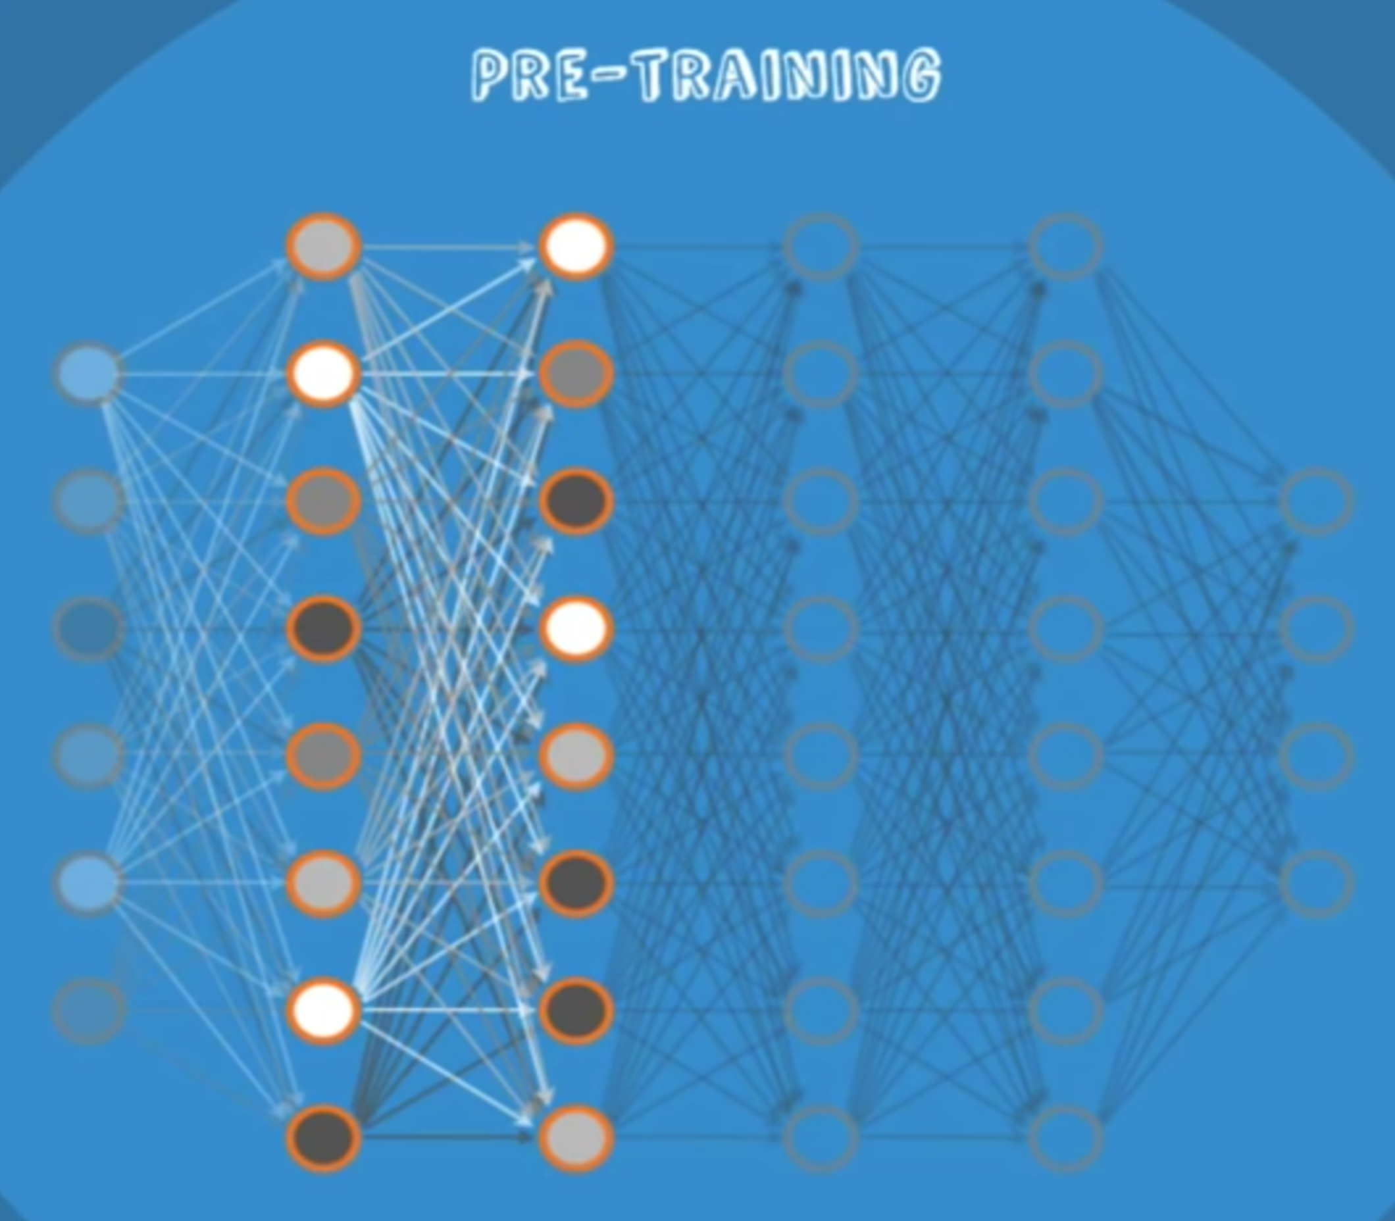

c) This process is repeated until every layer in the network is trained

An important note about a DBN is that each RBM layer learns the entire input.

In other kinds of models – like convolutional – early layers detect simple patterns and later layers recombine them. Like in our facial recognition example, the early layers would detect edges in the image, and later layers would use these results to form facial features.

A DBN, on the other hand, works globally by fine tuning the entire input in succession as the model slowly improves – kind of like a camera lens slowly focusing a picture. 如下:

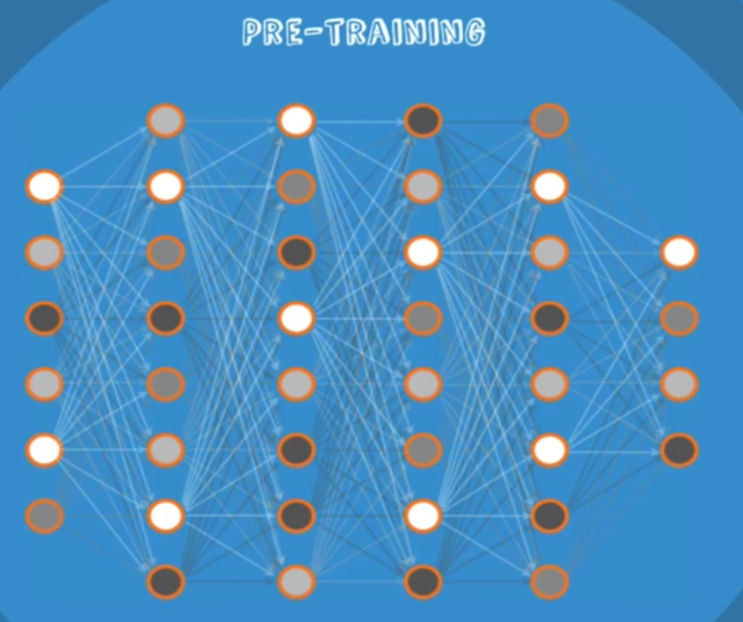

* 1. **微调训练:**

After this initial training, the RBMs have created a model that can detect inherent patterns in the data. But we still don’t know exactly what the patterns are called. To finish training, we need to introduce labels to the patterns and fine-tune the net with supervised learning. To do this, you need a very small set of labeled samples so that the features and patterns can be associated with a name. The weights and biases are altered slightly, resulting in a small change in the net’s perception of the patterns, and often a small increase in the total accuracy. Fortunately, the set of labelled data can be small relative to the original data set, which as we’ve discussed, is extremely helpful in real-world applications.如下:

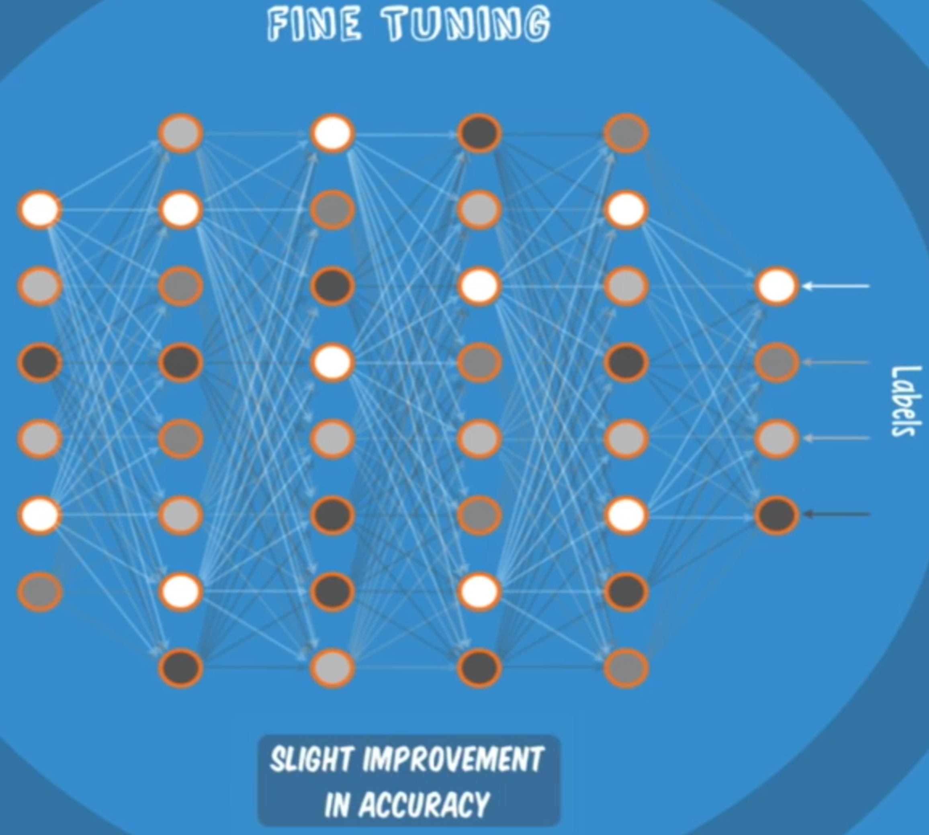

* 1. **优点:**

So let’s recap the benefits of a Deep Belief Network. We saw that a DBN only needs a small labelled data set, which is important for real-world applications. The training process can also be completed in a reasonable amount of time through the use of GPUs. And best of all, the resulting net will be very accurate compared to a shallow net, so we can finally see that a DBN is a solution to the vanishing gradient problem!

运算速度与浅网络差不多, 准确率更高.